**Practice Case Study**

**Sample application Design**

**Contents:**

1. Scope

2. User Interface screen designs

3. Class Diagram

4. Database Diagram

### Purpose & Scope of the document

The purpose of this document is to provide guidelines for developing a sample case study called

“Customer Management System”.

## Application ‘s User Interface

The application has the following screens:

Screen 1: Home / Landing Page

Screen 2:Contact Us

Screen 3:About Us

Screen 4: Terms And Policy

Screen 5:Registration Page

Screen 6:DisplayPage

Screen 7:Login Page

Screen 8:Login Success Page

Screen 9:Search Page

### Screen 1: Home / Landing page

##### User Story for home page/ landing page

|  |  |  |  |
| --- | --- | --- | --- |
| **CustomerID** | **As a** | **I want to be able to** | **so that** |
| Cust1 | Customer | see the actions that I can perform so that I can choose | to add a new customer, or create an account for an existing customer or ,to login, to display list of customers, to search for existing customer |

##### Sample UI Screen given below

##### Sample UI Screen given below

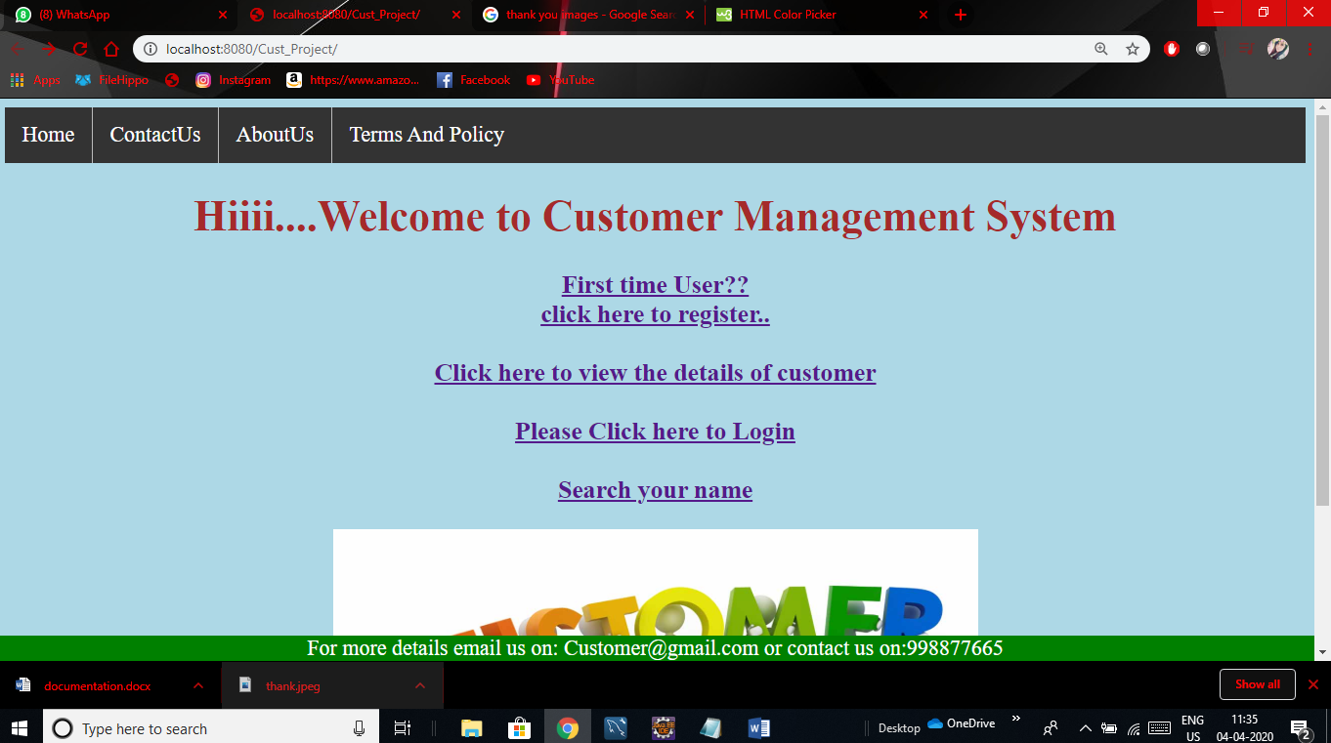

### Screen 2:Contact Us Page

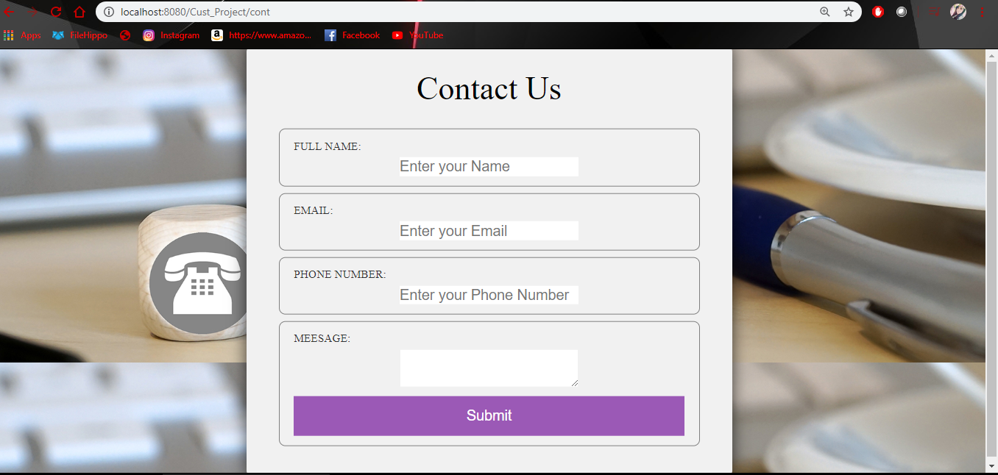

### Screen 3:About Us Page

### C:\Users\Administrator\Pictures\about.PNG

### Screen 4:Terms And Condition Page

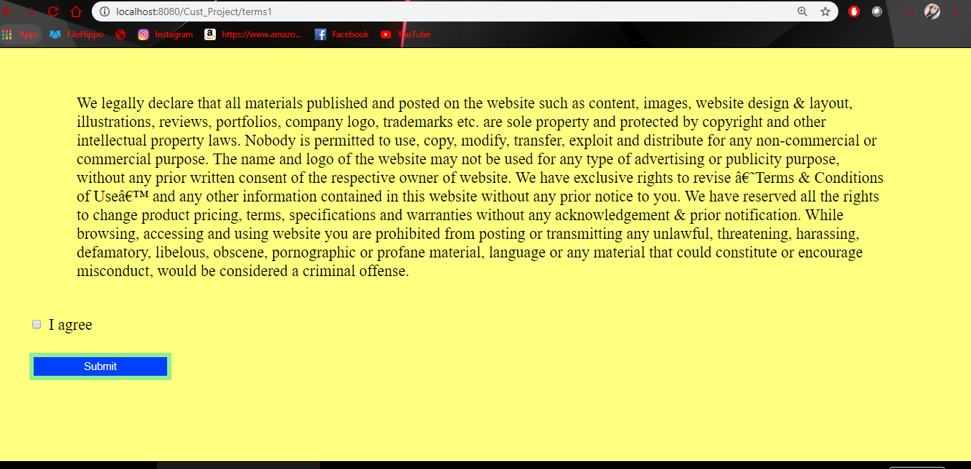

### Screen 5:Registration Page

|  |  |  |  |
| --- | --- | --- | --- |
| **UserStory ID** | **As a** | **I want to be able to** | **so that** |
| Cust1 | Customer | As An Customer I want to register into the application | I can use the features of this application |

|  |  |  |  |
| --- | --- | --- | --- |
| **UserStory ID** | **As a** | **I want to be able to** | **so that** |
| Cust1 | Customer | I should be able to create a new customer for my bank. I will be providing the details like firstname, lastname,age, gender,contact number etc. | a new customer is added to the account |

##### Field Specification

|  |  |  |
| --- | --- | --- |
| **FieldName** | **FieldType** | **Description** |
| CustomerID | Text box | It accepts the customer Id |
| AccountType | Dropdown | Helps to choose the account type |

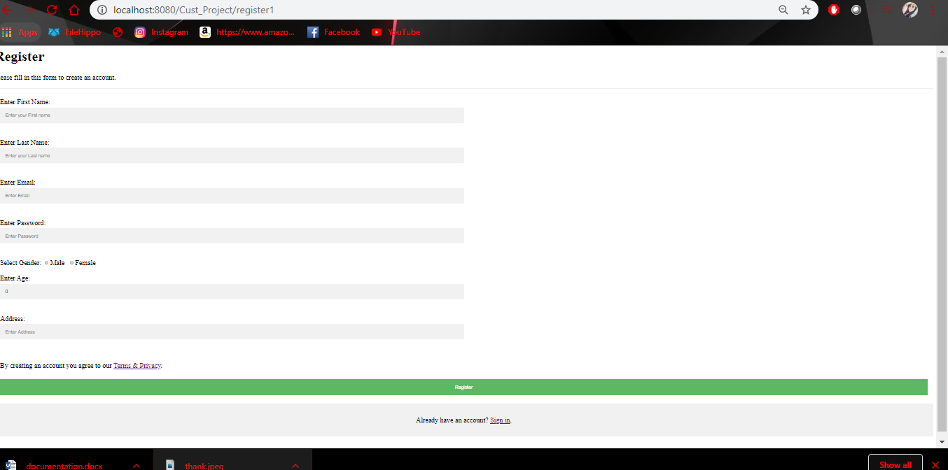

### Screen 6:Display Page

### C:\Users\Administrator\Pictures\detail.PNG

### Screen 7: Login page

##### User Story for Login page

|  |  |  |  |
| --- | --- | --- | --- |
| **UserStory ID** | **As a** | **I want to be able to** | **so that** |
| Cust1 | Customer | As An Customer I want to login into the application | I can use the features of this application |

### 

### Screen 8: Login Success page

### Sample UI Screen given below

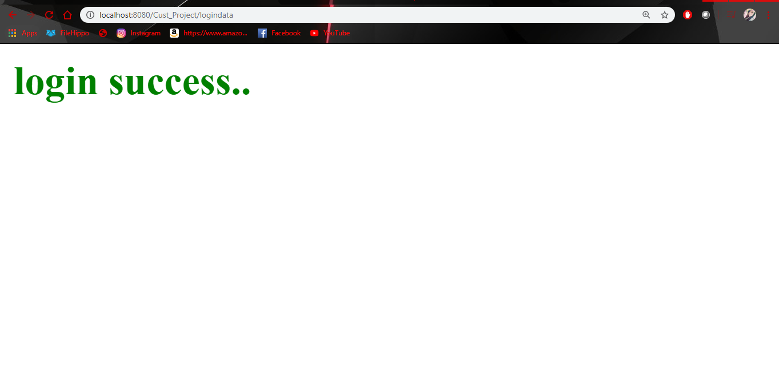

### Screen 9: Search page

Sample UI Screen given below

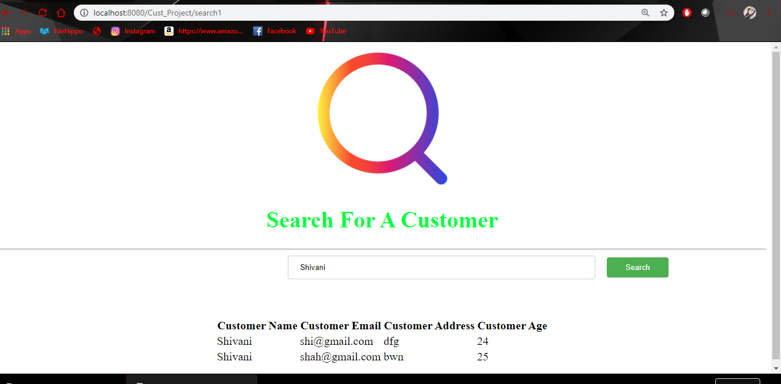

## Class Diagram

|  |
| --- |
| Customer |
| Customer Id: Cust-id(int) |
| Customer First Name: Cust-fname(varchar) |
| Customer Last Name: Cust-lname(varchar) |
| Customer Gender: Gender(varchar) |
| Customer Password: Cust-pass(varchar) |
| Customer Email: Cust-email(varchar) |
| Customer Address : Cust-address(varchar) |
| Customer Age: Cust-age(int) |

## Database design diagram

|  |
| --- |
| Cust_info |
| Cust-id(int) |
| Cust-fname(varchar) |
| Cust-lname(varchar) |
| Gender(varchar) |
| Cust-pass(varchar) |
| Cust-email(varchar) |
| Cust-address(varchar) |
| Cust-age(int) |